cetcue1c HD:Users:faculty:Desktop:CIS final logo.pdf

**Middle Years**

**An International Baccalaureate MYP Candidate Programme**

**CIS Mission Statement**

The mission of Campus International School is to develop inquiring, knowledgeable, life-long learners, who have the courage to act responsibly to make the world a better place.

***What is the IB Middle Years Programme?***

The MYP is a challenging academic program that encourages students to become creative, critical and reflective thinkers. The program builds connections between subject areas and the real world and is designed to develop the skills needed for our global society and foster international-mindedness in our students. We are currently in the candidate phase of the MYP authorization process, implementing all major components of the IB MYP.

***What does it mean to be internationally minded?***

International Mindedness begins with the lB Learner Profile:

|  |  |  |  |  |
| --- | --- | --- | --- | --- |
| Inquirers | Knowledgeable | Thinkers | Communicators | Principled |
| Caring | Open-Minded | Balanced | Risk-Takers | Reflective |

It is further developed as students explore the MYP Global Contexts and become aware that the world includes our community and is also much larger than our own community. At Campus International students continue to develop respect and intercultural understanding through MYP units.

***Learning in context with conceptual understanding***

Students complete coursework in 8 subject groups through concept based units. In each subject group students focus on any of 16 concepts, along with subject specific related concepts. The following concepts are recommended by the IB for each subject area.

|  |  |
| --- | --- |
| The Arts | Aesthetics Change Communication Identity |
| Individuals and Societies | Change Global Interactions Systems Time, place and space |
| Language Acquisition | Communication Connections Creativity Culture |
| Language and Literature | Communication Connections Creativity Perspective |
| Mathematics | Form Relationships Logic |
| PE and Health | Change Communications Relationships |
| Science | Change Relationships Systems |
|  |  |

Information retrieved from the International Baccalaureate at www.ibo.org

***Global Contexts***

|  |  |
| --- | --- |
| Identities and Relationships | Scientific and Technical Innovation |
| Orientation in Time and Space | Globalization and Sustainability |
| Personal And Cultural Expression | Fairness and Development |

***Approaches to Learning***

The Approaches to Learning are another important component of MYP units. These are similar to transdisciplinary skills in PYP. ATL’s are taught and practiced across the curriculum

Approaches to Learning

|  |  |
| --- | --- |
| Communication Skills |  |
| Social Skills | Collaboration |
| Self- Management Skills | Organization Affective Reflection |
| Research Skills | Information Literacy Media Literacy |
| Thinking | Critical thinking Creative thinking Transfer |

***Service as Action***

Action and service are core values of the IB and students are always taking action when they apply their learning inside the classroom and out. MYP students become more intentional with their action through the incorporation of service as action in many of their units and the community project in grade 8.

***The Design Cycle***

Students incorporate the design cycle in all subject areas and will begin to use it as guide when planning service, projects and other activities. It is similar to the Action Cycle in PYP.

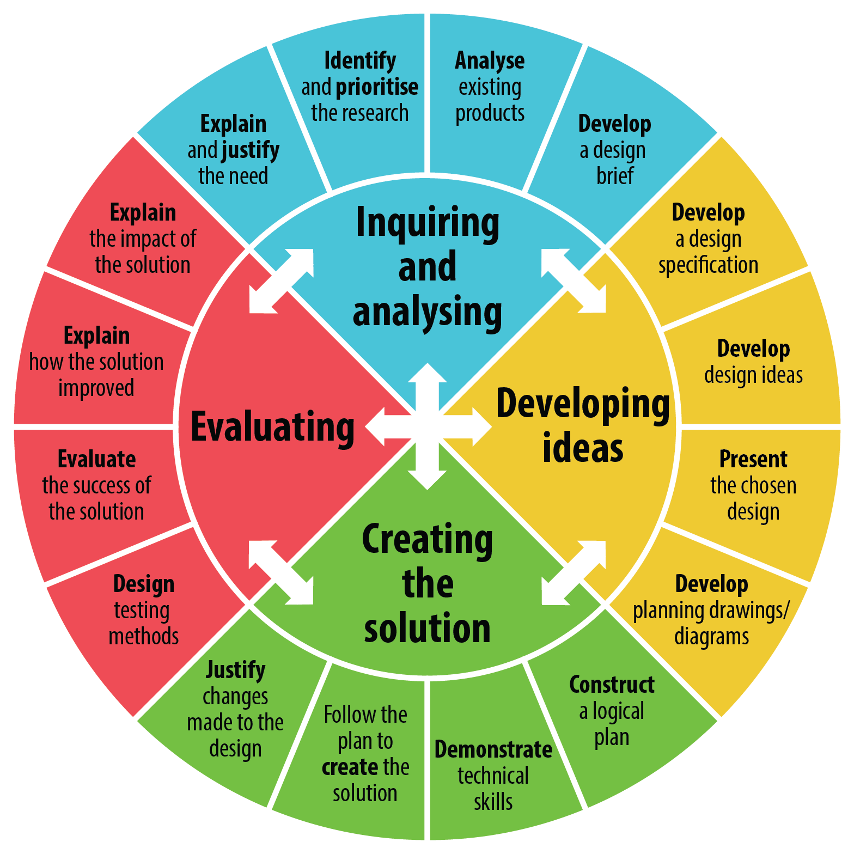  
Image taken from <http://www.jasonunderwood.com/tag/design-technology/>

For more information about the IB and MYP visit: [www.ibo.org](http://www.ibo.org)

Information retrieved from the International Baccalaureate at [www.ibo.org](http://www.ibo.org)